**HVAC DISTRIBUTORS & DAIKIN SUITE NIGHT**

**WITH THE STATE COLLEGE SPIKES 2024**

* August 15th, 2023
* Gates Open at 5:25- Food & Drinks will be served at the Picnic Pavilion in Left Field outfield area at 5:30.
* Game starts at 6:35
* 112 Medlar Field, University Park, Pennsylvania 16802
* Bring Five Dollars to Park
* If the weather causes issues with the game, we will reschedule and advise once we hear from the team.

**HOW TO GET IN**

* Go to Will Call Ticket Pickup
* Say you are with HVAC DISTRIBUTORS and give your company name that you gave to get your tickets, we have a spreadsheet with each dealer’s ticket total that was given to the Spikes. You will get a wristband there for our picnic area.

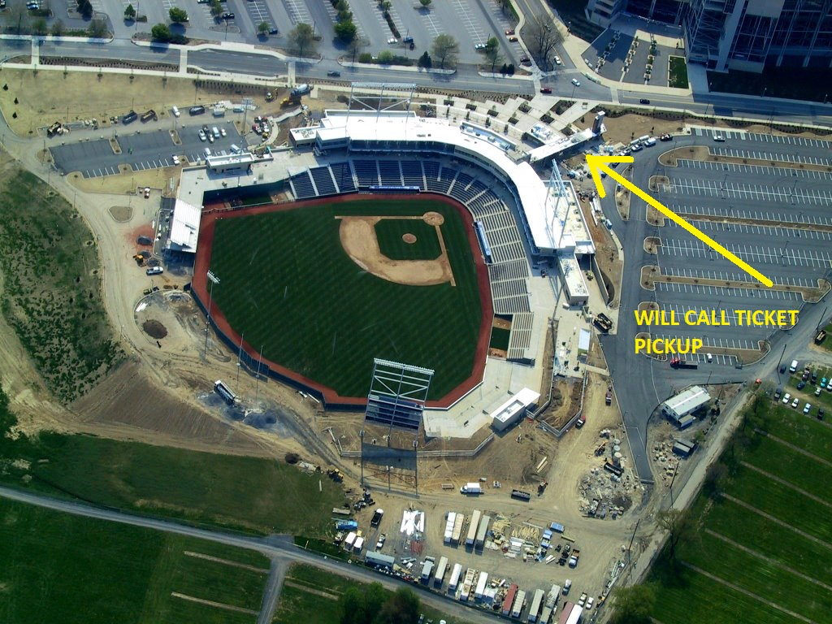

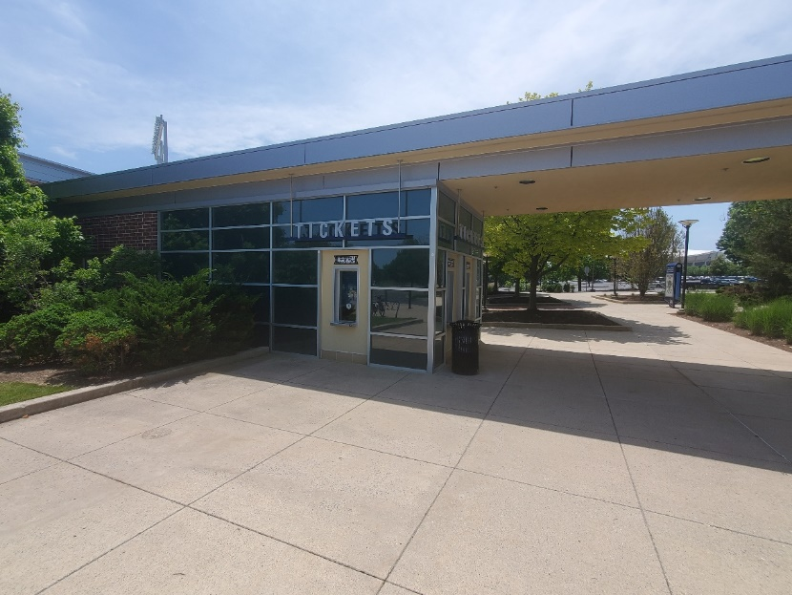

* Take Ticket through Gate B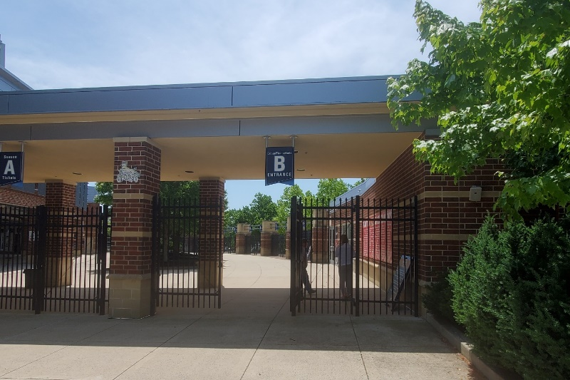
* Go out behind left field for food and drinks at our area and have fun with us! After you get something to eat, we will all sit in the outfield and watch the Spikes PLAY BALL!

